
MY PERSONAL PORTFOLIO
The only person you are destined to become is the person you decide to be.
April 30, 2025


My name is M.Junaid. I have a small family mother, father and one sister. My age is 12 and my date of birth is 23rd July 2013. I am the student of class 7 and I was studying in school call Montessori Complex High School. My interests was in AI and software engineering so I recently join classes in very famous institute Aptech and my aim was to become a software engineer. I have few hobbies also some of them are playing cricket, singing, dancing and reading etc.
My daily routine

Monday | Tuesday | Wednesday | Thursday | Friday | Saturday
School | School | School | School | School | Break
Sleep | Sleep | Sleep | Sleep | Sleep | Learning some new skills
Doing homework | Doing homework | Doing homework | Doing homework | Doing homework | Free  time
Learning some new skills | Learning some new skills | Learning some new skills | Learning some new skills | Learning some new skills | Free  time

My skills
- Playing cricket
- Singing
- Dancing
- Reading
- Communication
- Manage the work load

Techskills
Year 2025

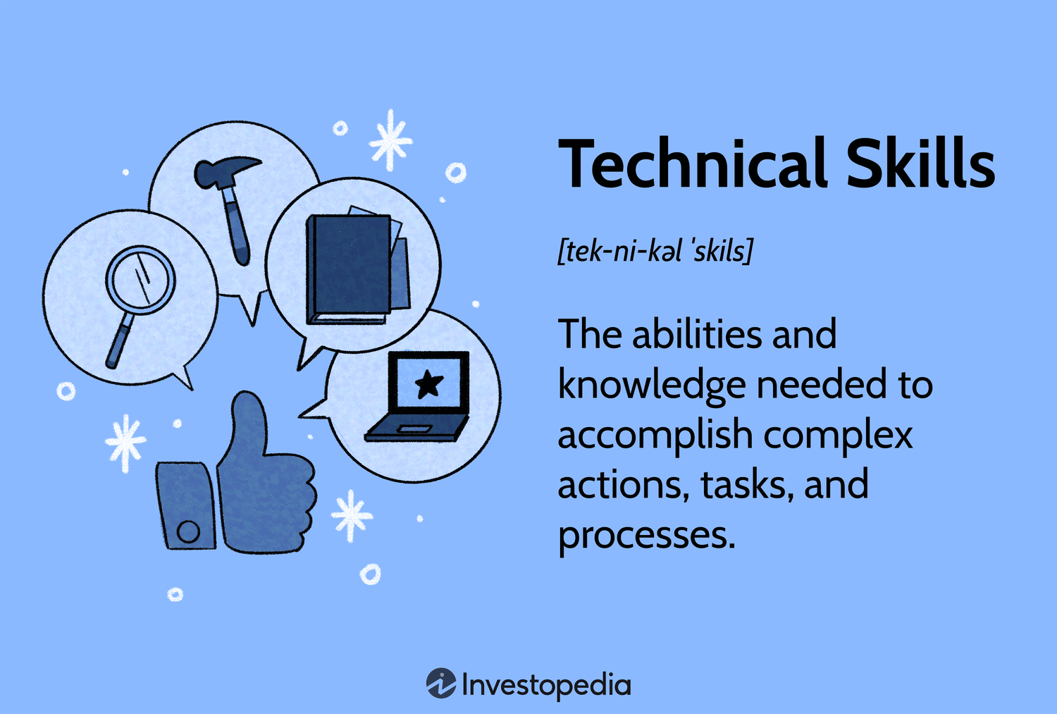
Tech skills refer to the ability to use, manage, and understand technology effectively, including areas like programming, data analysis, cybersecurity, cloud computing, and hardware. These skills are essential in today's digital world for solving problems, optimizing processes, and driving innovation across industries

My dream job

Software engineering is my dream job because it blends problem-solving, creativity, and continuous learning. The field is constantly evolving, offering opportunities to grow and work across diverse industries like healthcare, gaming, and finance. I enjoy the challenge of breaking down complex problems and collaborating with teams to create meaningful solutions.
What excites me most is the potential to make a real-world impact through software—whether it's improving daily life or contributing to important industries. Plus, with tech growing rapidly, there’s strong job stability and endless room for specialization and growth. Ultimately, software engineering offers a fulfilling career that combines learning, innovation, and making a difference.

